Chapter 12, Solution 43.

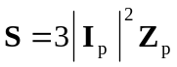, 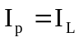 for Y-connected loads

